Processes of Memory - Encoding
# Source: AI Source: Provided by: [Data Path: Persons Table -> ID Column: 1, Name_En Column: Motasem Essam] -> From: [ChatGPT] on [5/1/2026]
Encoding (the first process of memory)
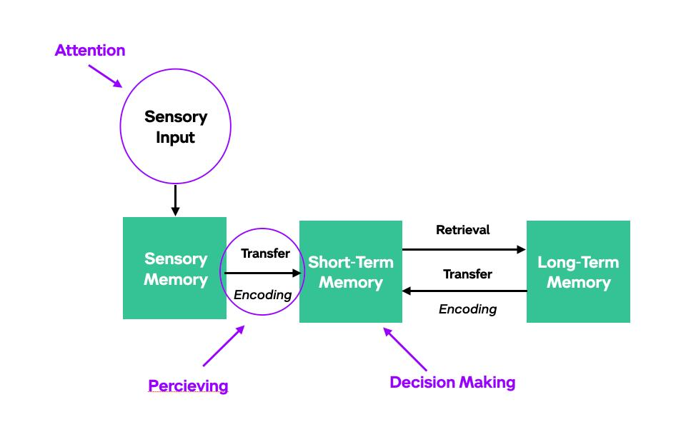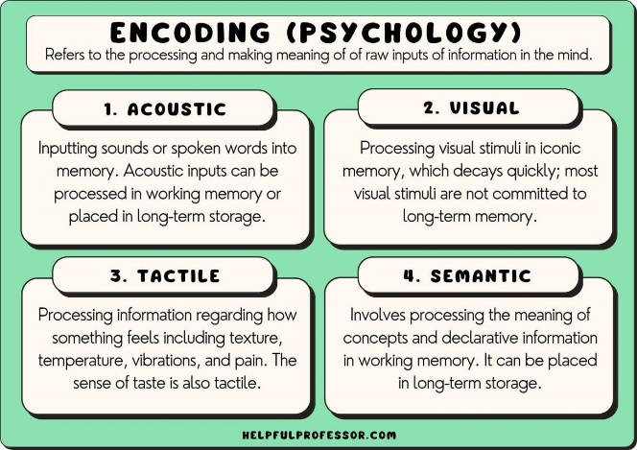
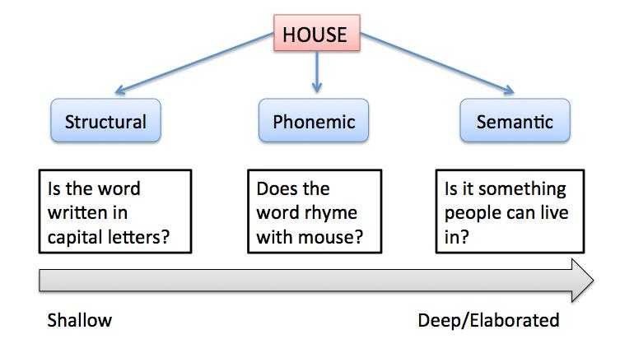
Encoding is how your brain transforms incoming information into a form that can be stored. It’s not just “taking in” information—it’s actively interpreting and organizing it.

Types of Encoding

1. Visual encoding
# Source: AI Source: Provided by: [Data Path: Persons Table -> ID Column: 1, Name_En Column: Motasem Essam] -> From: [ChatGPT] on [5/1/2026]
  - Processing images, shapes, colors
  - Example: remembering a face or a diagram

2. Acoustic encoding
# Source: AI Source: Provided by: [Data Path: Persons Table -> ID Column: 1, Name_En Column: Motasem Essam] -> From: [ChatGPT] on [5/1/2026]
  - Processing sounds, especially language
  - Example: remembering a song or repeating something out loud

3. Semantic encoding (most powerful)
# Source: AI Source: Provided by: [Data Path: Persons Table -> ID Column: 1, Name_En Column: Motasem Essam] -> From: [ChatGPT] on [5/1/2026]
  - Processing meaning and understanding
  - Example: linking a new concept to something you already know

Levels of Processing (Why some memories stick)
# Source: AI Source: Provided by: [Data Path: Persons Table -> ID Column: 1, Name_En Column: Motasem Essam] -> From: [ChatGPT] on [5/1/2026]
Psychologist Fergus Craik and Robert Lockhart proposed that memory depends on how deeply information is processed:
- Shallow encoding → based on appearance or sound
(e.g., “Does this word rhyme?”)
- Deep encoding → based on meaning
(e.g., “What does this word mean?”)
👉 Deeper (semantic) encoding leads to stronger, longer-lasting memories.

Factors That Affect Encoding
# Source: AI Source: Provided by: [Data Path: Persons Table -> ID Column: 1, Name_En Column: Motasem Essam] -> From: [ChatGPT] on [5/1/2026]
- Attention
If you’re distracted, encoding is weak or doesn’t happen at all.
- Repetition (maintenance rehearsal)
Repeating information helps, but mainly for short-term retention.
- Elaboration (elaborative rehearsal)
Connecting new info to existing knowledge strengthens encoding.
- Organization
Grouping information (chunking) makes it easier to encode.
- Emotion
Emotional events are often encoded more strongly.

Optimal Encoding (how to encode information most effectively)
# Source: AI Source: Provided by: [Data Path: Persons Table -> ID Column: 1, Name_En Column: Motasem Essam] -> From: [ChatGPT] on [5/1/2026]
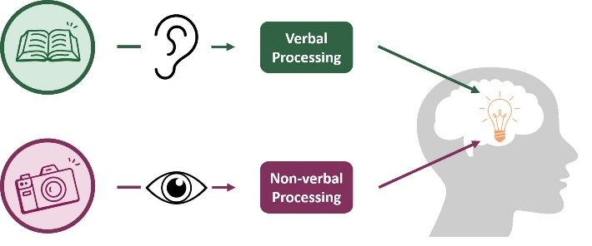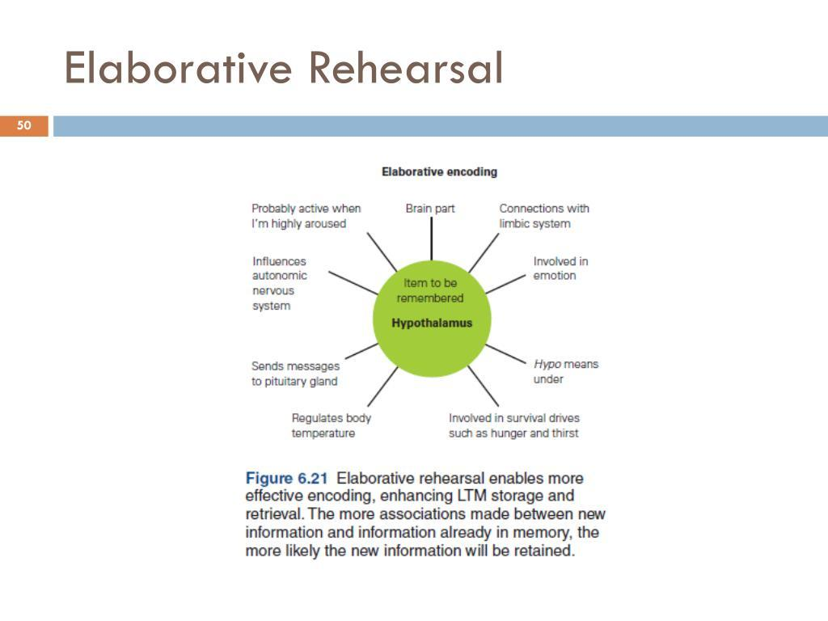
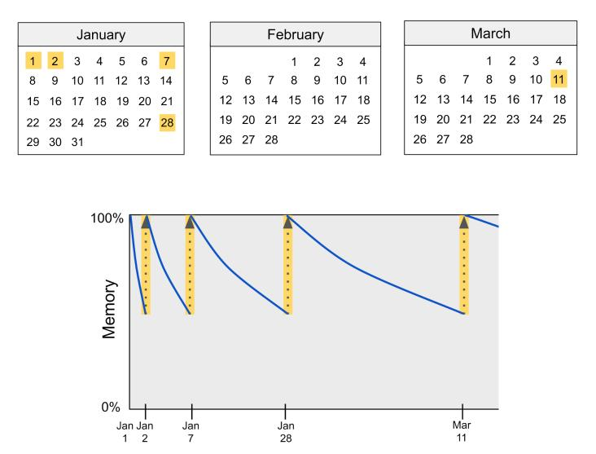
Optimal encoding means using strategies that make information meaningful, well-organized, and easy to retrieve later. The goal isn’t just to take in information—but to encode it in a deep and durable way.

1. Deep (Semantic) Processing
# Source: AI Source: Provided by: [Data Path: Persons Table -> ID Column: 1, Name_En Column: Motasem Essam] -> From: [ChatGPT] on [5/1/2026]
The most effective encoding happens when you focus on meaning, not just appearance or sound.
- Ask: What does this mean? Why does it matter?
- Connect new ideas to what you already know
This idea comes from the levels of processing theory by Fergus Craik and Robert Lockhart.
👉 Deeper processing = stronger memory

2. Elaborative Rehearsal
# Source: AI Source: Provided by: [Data Path: Persons Table -> ID Column: 1, Name_En Column: Motasem Essam] -> From: [ChatGPT] on [5/1/2026]
Instead of repeating information, expand on it:
- Create examples
- Explain it in your own words
- Teach it to someone else
This strengthens connections in long-term memory.

3. Organization
# Source: AI Source: Provided by: [Data Path: Persons Table -> ID Column: 1, Name_En Column: Motasem Essam] -> From: [ChatGPT] on [5/1/2026]
Structured information is easier to encode and store.
- Use chunking (grouping items)
- Create outlines or mind maps
- Break complex info into categories
Example: remembering a phone number as chunks instead of single digits.

4. Dual Coding (Visual + Verbal)
# Source: AI Source: Provided by: [Data Path: Persons Table -> ID Column: 1, Name_En Column: Motasem Essam] -> From: [ChatGPT] on [5/1/2026]
Combine words and images:
- Diagrams, charts, or drawings
- Visualizing concepts while studying
This creates two memory pathways, making recall easier.

5. Self-Reference Effect
# Source: AI Source: Provided by: [Data Path: Persons Table -> ID Column: 1, Name_En Column: Motasem Essam] -> From: [ChatGPT] on [5/1/2026]
Relate information to yourself:
- “How does this apply to my life?”
- “Have I experienced something similar?”
This significantly boosts encoding strength.

6. Spacing Effect (Distributed Practice)
# Source: AI Source: Provided by: [Data Path: Persons Table -> ID Column: 1, Name_En Column: Motasem Essam] -> From: [ChatGPT] on [5/1/2026]
Study over time instead of cramming.
- Spread sessions out (hours/days)
- Review multiple times
Research by Hermann Ebbinghaus shows spaced learning improves long-term retention.

7. Attention and Focus
# Source: AI Source: Provided by: [Data Path: Persons Table -> ID Column: 1, Name_En Column: Motasem Essam] -> From: [ChatGPT] on [5/1/2026]
Encoding fails without attention.
- Remove distractions
- Study actively (not passively reading)

8. Emotion and Distinctiveness
# Source: AI Source: Provided by: [Data Path: Persons Table -> ID Column: 1, Name_En Column: Motasem Essam] -> From: [ChatGPT] on [5/1/2026]
- Emotional or unusual information is encoded more strongly
- Make material unique or surprising to remember it better

Simple Comparison
# Source: AI Source: Provided by: [Data Path: Persons Table -> ID Column: 1, Name_En Column: Motasem Essam] -> From: [ChatGPT] on [5/1/2026]
- ❌ Rereading notes passively → weak encoding
- ✅ Explaining concepts, using examples, spacing study → optimal encoding

Bottom Line
# Source: AI Source: Provided by: [Data Path: Persons Table -> ID Column: 1, Name_En Column: Motasem Essam] -> From: [ChatGPT] on [5/1/2026]
Optimal encoding happens when information is:
- Meaningful (deep processing)
- Connected (elaboration)
- Structured (organization)
- Revisited over time (spacing)

Computational Models of Memory Encoding
# Source: AI Source: Provided by: [Data Path: Persons Table -> ID Column: 1, Name_En Column: Motasem Essam] -> From: [ChatGPT] on [5/1/2026]
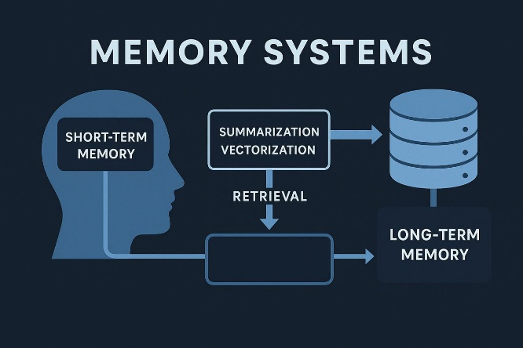
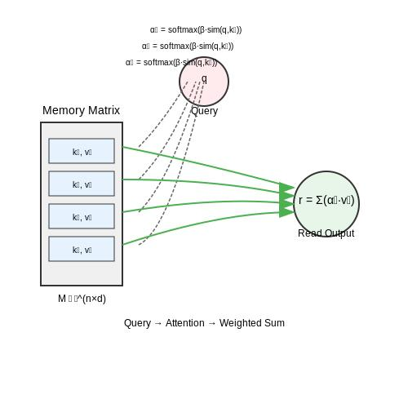
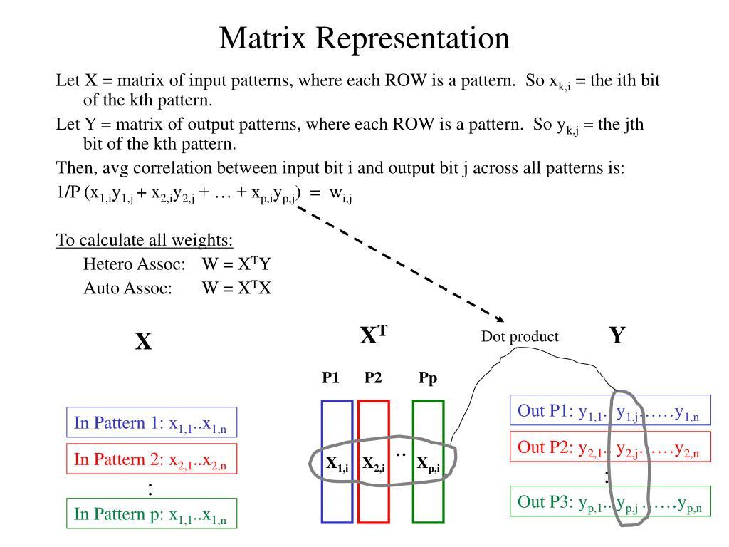
Computational models aim to simulate how information is encoded into memory using mathematical representations (vectors, probabilities, and associations). These models are often built to explain different memory tasks such as recognition, recall, and sequence learning.

1. Item Recognition Models
# Source: AI Source: Provided by: [Data Path: Persons Table -> ID Column: 1, Name_En Column: Motasem Essam] -> From: [ChatGPT] on [5/1/2026]
These models explain how we decide if something has been seen before.
- Each item is encoded as a vector of features (attributes) plus a context vector
- All encoded items are stored in a memory matrix
- During recognition:
  - The brain compares a new item to stored ones
  - If similarity exceeds a threshold → “recognized”
👉 Important idea:
- Memory encoding includes both the item and its context
- Recent items are easier to recognize because context changes over time
This approach is linked to multiple-trace theory and attribute-similarity models.

2. Cued Recall Models
# Source: AI Source: Provided by: [Data Path: Persons Table -> ID Column: 1, Name_En Column: Motasem Essam] -> From: [ChatGPT] on [5/1/2026]
These explain how hints (cues) help retrieve stored information.
- Encoding stores items as vectors (like recognition models)
- During storage, noise is added → explains errors
- Retrieval is probabilistic:
  - The more similar an item is to a cue, the more likely it is recalled
👉 Key insight:
- Encoding does not produce perfect copies—representations are imperfect and noisy
- Cues work by matching stored encoded features
Experiments by Endel Tulving showed cues significantly improve recall.

3. Free Recall Model (SAM – Search of Associative Memory)
# Source: AI Source: Provided by: [Data Path: Persons Table -> ID Column: 1, Name_En Column: Motasem Essam] -> From: [ChatGPT] on [5/1/2026]
This model explains how we recall information without cues.
- Based on the Atkinson–Shiffrin model
- Two stores:
  - Short-term store (STS)
  - Long-term store (LTS)
Encoding in SAM:
- Items enter STS first
- Items in STS form associations with each other
- Stronger associations → better encoding into LTS
👉 Explains:
- Primacy effect (early items remembered better)
- Recency effect (recent items still in STS)
Also, free recall involves more relational encoding, making it more effective for learning.

4. Sequence Memory Models
# Source: AI Source: Provided by: [Data Path: Persons Table -> ID Column: 1, Name_En Column: Motasem Essam] -> From: [ChatGPT] on [5/1/2026]
These models explain how we encode order of information (e.g., phone numbers).
(a) Associative Chaining
- Each item is linked to the next (and previous)
- Stronger links between nearby items
👉 Explains errors like swapping neighboring items

(b) Positional Coding
- Each item is encoded with its position in a sequence
- Items are also weakly linked to nearby positions
👉 Explains:
- Why first and last items are easier to recall
- Reduced competition at edges of a list

Limitations
# Source: AI Source: Provided by: [Data Path: Persons Table -> ID Column: 1, Name_En Column: Motasem Essam] -> From: [ChatGPT] on [5/1/2026]
- Neither model fully explains all memory errors (e.g., repeated items effects)
- Sequence encoding remains an active research area

Key Takeaways
# Source: AI Source: Provided by: [Data Path: Persons Table -> ID Column: 1, Name_En Column: Motasem Essam] -> From: [ChatGPT] on [5/1/2026]
Across these models, encoding is understood as:
- Vector-based → information represented as features
- Context-dependent → context is encoded alongside items
- Probabilistic → retrieval depends on similarity and noise
- Associative → links between items are critical

One-line Summary (Exam Ready)
# Source: AI Source: Provided by: [Data Path: Persons Table -> ID Column: 1, Name_En Column: Motasem Essam] -> From: [ChatGPT] on [5/1/2026]
Computational models describe encoding as storing items as feature–context vectors in a memory system, where recall and recognition depend on similarity, associations, and probabilistic processes.

Brain and Encoding
# Source: AI Source: Provided by: [Data Path: Persons Table -> ID Column: 1, Name_En Column: Motasem Essam] -> From: [ChatGPT] on [5/1/2026]
The hippocampus is key for converting short-term information into long-term memory. It works with other brain areas depending on the type of information (visual, auditory, emotional).

Simple Example
# Source: AI Source: Provided by: [Data Path: Persons Table -> ID Column: 1, Name_En Column: Motasem Essam] -> From: [ChatGPT] on [5/1/2026]
If you memorize the word “apple”:
- Shallow: noticing it’s 5 letters
- Acoustic: repeating “apple, apple…”
- Deep: thinking about taste, color, or linking it to a memory
➡️ The deeper approach is far more effective.

